Lab 4
Assembly Language

- Write a program to display the extended ASCII characters (ASCII codes 80h to FFh). Display 10 characters per line, separated by blanks. Stop after the extended characters have been displayed once. (LAB41.ASM)
Sample execution:
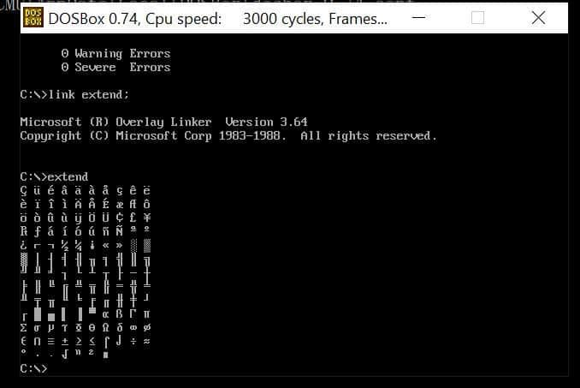
- Write a program to accept a single-digit integer, then display the message "The Great Pyramid of Giza" with the number of lines equal to the entered integer. (LAB42.ASM)
Sample execution:
Enter a number: 5
*
**
***
****
*****

